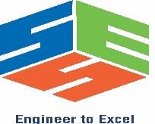

SIMATS ENGINEERING
Saveetha Institute of Medical and Technical Sciences Chennai- 602105
Student Name: Sanjay Kumar soy Reg. No.: 192311151
Course Code: CSA1522 Slot: C
Course Name: Cloud Computing & Big Data Analytics
Course Faculty: Dr. Rajaram P

Project Title: Multi-Tenant SaaS-Based Student Learning Management System
Module Photographs: (3 photographs –Module Photo, Individual student contribution module work in the project and presentation image)
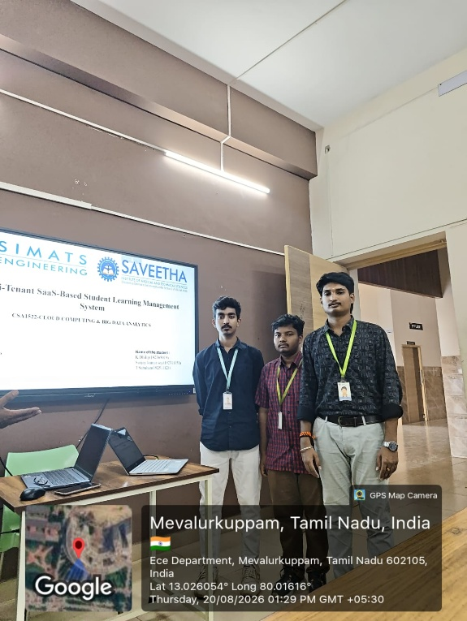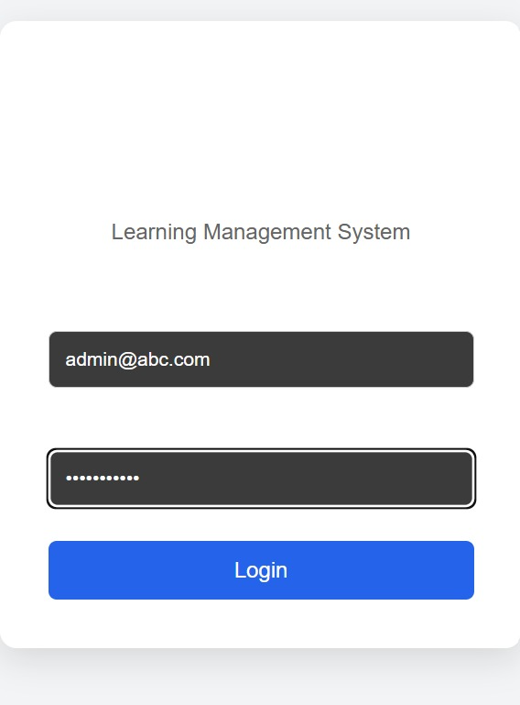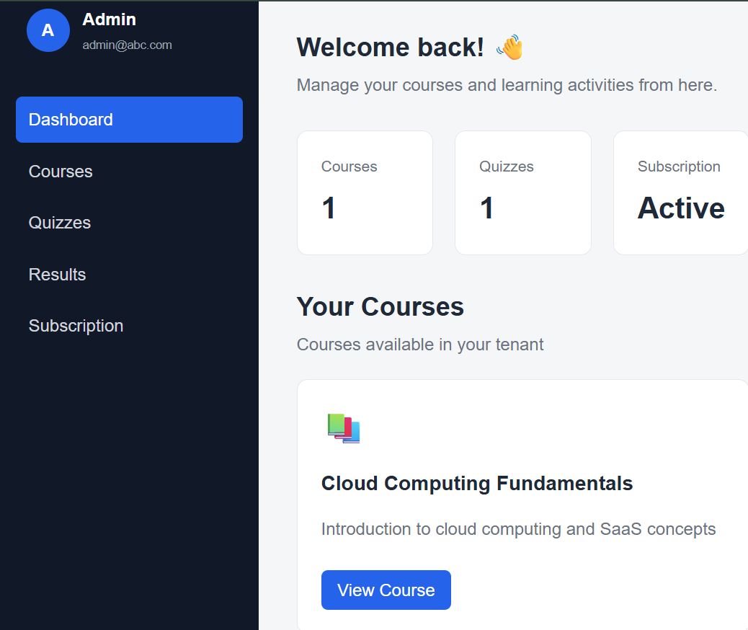
Project Description: (here you write what you did in this project (contribution) including Model Description
Worked on designing the multi-tenant structure of the LMS, allowing multiple institutions to use the same application while keeping their data separate and secure. Developed user registration, login, role-based access, and management of students, teachers, and administrators. focused on building the basic structure of the multi-tenant LMS and managing users. The work included separating data between different institutions and implementing secure login and access based on user roles. The student also handled the management of students, teachers, and administrators within each institution.

Student Signature Guide Signature

